Quality Policy
Echometer Company is committed to manufacture and service products used to analyze and optimize the performance of oil, gas, and water wells, and to meet the requirements of our customers, regulatory and accrediting bodies.
To ensure the success of our quality standards, Echometer employees and management are responsible for identifying and meeting customer, regulatory and accrediting bodies’ requirements.
Through continuous evaluation, we comply with the ISO 9001:2015 requirements and continually improve the effectiveness of the Quality Management System.

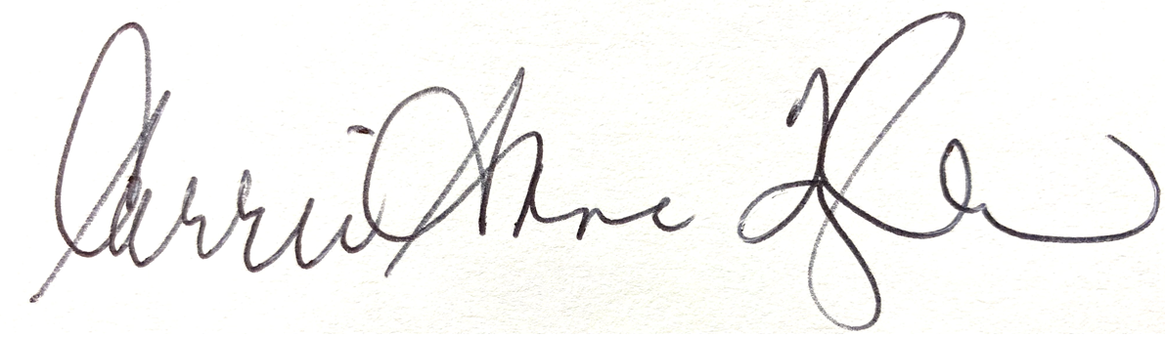
Carrie-Anne Taylor, Quality Assurance Manager
June 2021

